Conquer MG Fall Meeting 10/22/2017 – Advocate Lutheran General Hospital
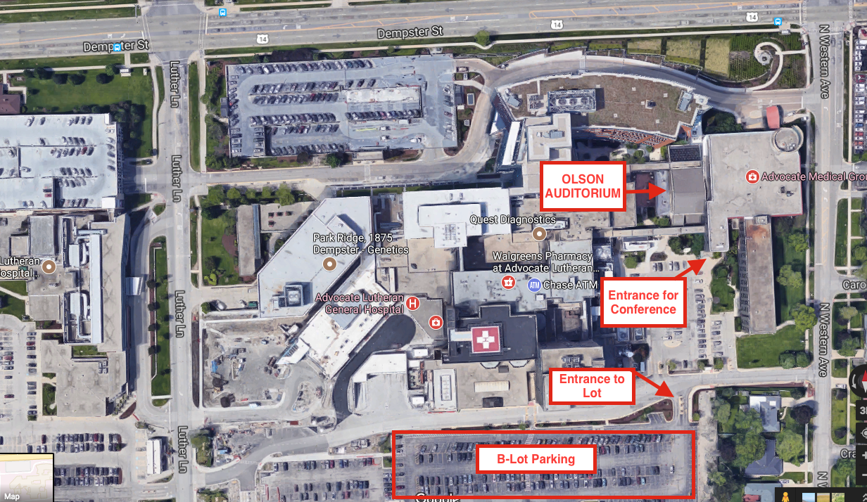

LOCATION – The hospital campus is in the northwest Chicago suburb of Park Ridge, on Dempster Street, about 1 mile east of Interstate 294. Coming from the south on I-294, take the Dempster East exit. Coming from the north on I-294, exit at IL-58 toward Golf Road, use left lanes to turn left onto East/SE River Road, left onto Ballard Rd., right onto Potter Road, left onto Dempster St.
PARKING and ENTRANCE:
- From Dempster Street, turn south onto Western Ave.
- Take the second hospital entrance on your right.
- The B-Lot Parking entrance will be on your left.
- The entrance for the conference is labeled “Advocate Children’s Hospital Outpatient Center.” Follow signs to Olson Auditorium.
