Frequently Asked Questions

What’s new for 2018?
- We’ve added a Viking theme – so we can Conquer MG together!
- A 5K Fun Run has been added for fitness warriors!
- Also, registration and fundraising will look different this year.
  - Registration will be through Active.com at https://endurancecui.active.com/new/events/52118651/select-race?_p=10079749591680565.
  - Fundraising will take place through https://www.crowdrise.com/6th-annual-strides-against-mg-runwalk.

What is Conquer Myasthenia Gravis?
Conquer Myasthenia Gravis (Conquer MG for short) is an independent state-based organization, serving MG patients primarily in Illinois, northwest Indiana, and southeast Wisconsin.

What is the Strides Against MG Walk?
Conquer MG hosts this event to raise awareness about myasthenia gravis. As we reach out to walkers, volunteers and sponsors, an ever-growing number of people know about MG. This leads to quicker diagnoses and more effective treatment for those who suffer with this rare autoimmune disease. The event also is Conquer MG’s primary fundraising activity for the year.

How is the money used?

Your registration fees and the donations you raise help pay for local Illinois, Indiana, and Wisconsin services like our education sessions, seven support groups, Patient Assistance Program, and MG packets for neurologists. Your donations reach MG patients beyond this area, too, helping to maintain open-access patient resources like the website www.myastheniagravis.org, YouTube channel “Conquer Myasthenia Gravis,” and constant updates on our Facebook page. And your donations fund research that gives innovative MG pilot projects a starting boost. We can’t say “Thank you!” enough!

Do I have to register to participate?
Each person who runs or walks must be registered. However, if you prefer, you can make a donation without registering.

Do I register my family?
Yes, each person who walks must be registered.

Do I have to register if I just want to fundraise?
No, registration is not required for donations or fundraising.

How do I register?
There are three ways to register in advance:
- Visit our online registration page. You’ll receive a confirmation email when you’re done.
- Call the Conquer MG office at 1-800-888-6208 to register by phone.
- Print a registration form that can be returned by mail. The link for this form is at http://www.myastheniagravis.org/wp-content/uploads/2018/03/2018walkform.docx. Your form must be received no later than June 1.
Online registration closes Friday, June 1, at 5pm.

Can I register on the day of the walk?
Yes. It will cost a little extra. Just head to the New Registration table.

What is the cost to register?
Adults: $35 ($40 on walk day)
Child under age 12: $15

Are my registration fees and extra donations tax-deductible?
Conquer MG is a tax-exempt 501(c)(3) organization (Tax ID# 23-7282572). Please note that $15 of each registration fee covers the cost of the event and is not tax-deductible. Registration fees over this amount (for example, $20 of a $35 adult fee) and any additional donation you make to Conquer MG are tax deductible as charitable contributions to the fullest extent of the law.

Can I walk on my own?
Absolutely. You can walk on your own, with a friend, or with a clan.

How do I create a team or join someone else’s team?
When you register, you’ll be asked:
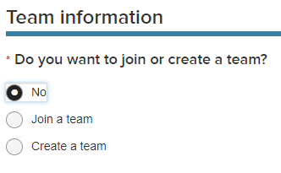

The team captain should create the team, then it will be listed for future enrollees to sign up.

How big or how small can a team be?
You can be a mighty team of one and set up a cool name, or gather as many folks as you like to walk with you.

Do I have to create a team?
No. Just say “No.”

What if I can’t walk? Can I raise money for the cause?
Any funds you raise help Conquer MG support MG patients, and would be greatly appreciated.

- You can make a donation at http://www.myastheniagravis.org/donate-to-the-cause/.
- You can invite others to support your cause. Create your own fundraising page (or a page for your team) at https://www.crowdrise.com/6th-annual-strides-against-mg-runwalk. On this page, click:
You’ll have this choice:
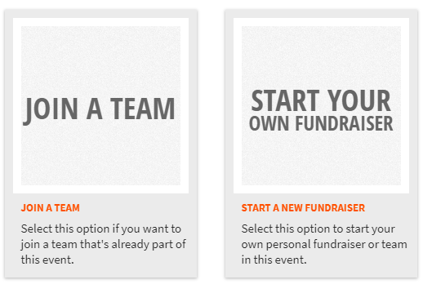
You’ll be guided through the prompts to raise funds as a team or as an individual. It’s a chance to tell your story about why this cause matters to you. Then share your page with friends, family and co-workers, and invite them to support your efforts.

- Last, you can donate to a team’s or person’s fundraising page. Visit https://www.crowdrise.com/6th-annual-strides-against-mg-runwalk; then click the orange donate box:

How do I turn in donations?
Funds raised online automatically go to Conquer MG. You can bring funds you raise offline with you to the run/walk. Or you can mail them to Conquer Myasthenia Gravis, 275 N. York Street, Suite 401, Elmhurst, IL 60126. Be sure to include the name of the walker and/or team so we can add these amounts to your team fundraising total.

To whom do I make checks payable?
Please make checks payable to Conquer Myasthenia Gravis.

Do I have to raise money to participate?
There is no minimum fundraising requirement to participate in the Strides walk. We ask that you challenge yourself, however, and invite 10 friends and family members to join your team or donate. You’ll be surprised how many people are willing to support your efforts.

What if I just want to donate to Conquer MG?
Visit www.myastheniagravis.org and click on the blue Donate button. Or mail your check payable to Conquer Myasthenia Gravis to 275 N. York Street, Suite 401, Elmhurst, IL 60126.

How long is the event?
Registration starts at 7:30 a.m. and the event ends at 10:30 a.m.

Where can I park?
There are two entrances to Berens Park, on Oaklawn Avenue (west side) and Walnut Avenue (east side). Each side has its own parking lot. There is extra parking to the north of Berens Park at the Joanne Wagner Community Center.

How can I find the starting location of the walk?
Look for the big white tent behind the park’s central (and only) building.

What if it rains on walk day?
The walk will take place rain or shine! We’ll have access to the park building in case of rain, and may need to postpone the walk temporarily. If this happens, we’ll have updates every 15 minutes or so.

