Frequently Asked Questions
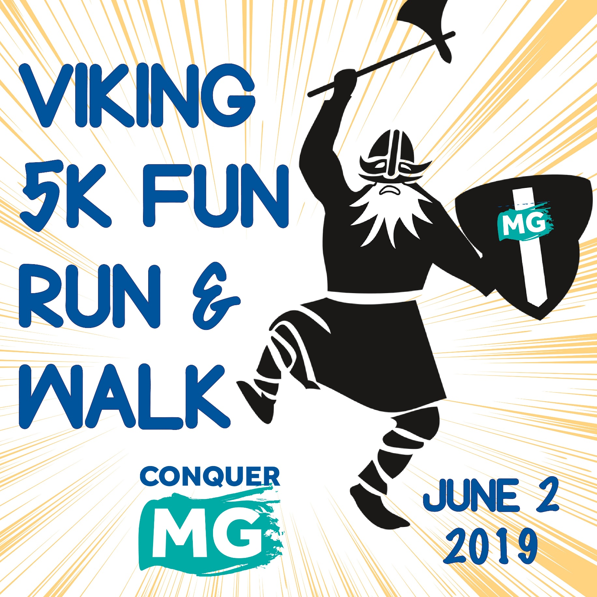
General Questions
How to Create A Team
How to Donate
How to Become a Fundraiser

GENERAL QUESTIONS
What is Conquer Myasthenia Gravis?
Conquer Myasthenia Gravis (Conquer MG for short) is an independent state-based organization, serving MG patients primarily in Illinois, northwest Indiana, and southeast Wisconsin.

What is the Viking 5K Fun Run/Walk?
Conquer MG hosts this event to raise awareness about myasthenia gravis. As we reach out to walkers, volunteers and sponsors, an ever-growing number of people know about MG. This leads to quicker diagnoses and more effective treatment for those who suffer with this rare autoimmune disease. The event also is Conquer MG’s primary fundraising activity for the year.

How is the money used?

Your registration fees and the donations you raise help pay for local Illinois, Indiana, and Wisconsin services like our education sessions, seven support groups, Patient Assistance Program, and MG packets for neurologists. Your donations reach MG patients beyond this area, too, helping to maintain open-access patient resources like the website www.myastheniagravis.org, YouTube channel “Conquer Myasthenia Gravis,” and constant updates on our Facebook page. And your donations fund research that gives innovative MG pilot projects a starting boost. We can’t say “Thank you!” enough!

Do I have to register to participate?
Each person who runs or walks must be registered. However, if you prefer, you can make a donation without registering.

Do I register my family?
Yes, runners, walkers, and spectators must be registered.

Do I have to register if I just want to fundraise?
No, registration is not required for donations or fundraising.

How do I register?
There are three ways to register in advance:
- Visit our online registration page. You’ll receive a confirmation email when you’re done.
- Call the Conquer MG office at 1-800-888-6208 to register by phone.
Print a registration form that can be returned by mail. The link for this form is at https://www.myastheniagravis.org/wp-content/uploads/2019/04/2019walkformC.docx
- Your form must be received no later than Monday, May 27.
Online registration closes Friday, May 31, at 5pm.

Can I register on the day of the walk?
Yes. It will cost a little extra. Just head to the New Registration table.

Are my registration fees and extra donations tax-deductible?
Conquer MG is a tax-exempt 501(c)(3) organization (Tax ID# 23-7282572). Please note that $20 of each registration fee covers the cost of the event and is not tax-deductible. Registration fees over this amount (for example, $15 of a $35 adult fee) and any additional donation you make to Conquer MG are tax deductible as charitable contributions to the fullest extent of the law.

Can I walk on my own?
We love individualism! Be independent, come with a friend, or bring a clan.

How do I create a team or join someone else’s team?
When you register, you’ll be asked
- For your basic info
- Choose your event (run, walk, Kids Dash)
- Would you like to join a Group/Team? If you choose “yes,” you’ll find the list of teams.

The team captain should register first and create the team. Then it will be listed for future enrollees to sign up.

How big or how small can a team be?
You can be a mighty team of one and set up a cool name, or gather as many folks as you like to walk with you.

Do I have to create a team?
No. Just say “No.”

What if I can’t walk? Can I raise money for the cause?
Any funds you raise help Conquer MG support MG patients, and would be greatly appreciated.

- You can make a donation at http://www.myastheniagravis.org/donate-to-the-cause/.
- You can invite others to support your cause. Create your own fundraising page (or a page for your team) at https://runsignup.com/Race/IL/Wheaton/Viking5KRunWalk. Just click the yellow Donate button. You’ll be guided through the prompts to raise funds as a team or as an individual. It’s a chance to tell your story about why this cause matters to you. Then share your page with friends, family and co-workers, and invite them to support your efforts.

- Last, you can donate to a team’s or person’s fundraising page. Visit https://runsignup.com/Race/Donate/IL/Wheaton/Viking5KRunWalk; then click the yellow donate box. Choose from the fundraiser pages listed.

How do I turn in donations?
Funds raised online automatically go to Conquer MG. If you receive a check, you can list this on your fundraising page – review the instructions for updating your page sent via email from RunSignUp. You can bring funds you raise offline with you to the run/walk. Or you can mail them to Conquer Myasthenia Gravis, 275 N. York Street, Suite 401, Elmhurst, IL 60126. Be sure to include the name of the walker and/or team so we can add these amounts to your team fundraising total.

Can donations be added manually to my fundraiser page?
Yes. The office can add an amount to your page once they receive a check designated for your fundraiser.

To whom do I make checks payable?
Please make checks payable to Conquer Myasthenia Gravis.

Do I have to raise money to participate?
There is no minimum fundraising requirement to participate in the Viking 5K. We ask that you challenge yourself, however, and invite 10 friends and family members to join your team or donate. You’ll be surprised how many people are willing to support your efforts.

What if I just want to donate to Conquer MG?
Visit www.myastheniagravis.org and click on the blue Donate button. Or mail your check payable to Conquer Myasthenia Gravis to 275 N. York Street, Suite 201, Elmhurst, IL 60126.

How long is the event?
Registration starts at 7:15 a.m. and the event ends at 10:30 a.m.

Where can I park?
Danada Forest Preserve has its own parking lot.

What if it rains on event day?
The Run/Walk will take place rain or shine! If it rains, we may need to postpone temporarily. If this happens, we’ll have updates every 15 minutes or so.

HOW TO DONATE
To make a simple donation
- Click Donate – either the yellow button, or in the navigation menu
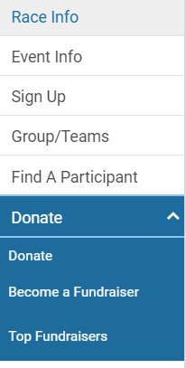
- Enter your donation amount
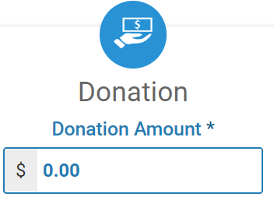
- Follow the rest of the prompts. Thank you very much!
To assign your donation to a team or person
- Click “Donate” as above.
- Scroll down and click the blue “Fundraiser” band.
- Fundraising individuals and teams will appear. “Select” your choice. If you don’t see the person or team, then use the Search function. (They might be listed on the next page.)
- Enter a donation amount. Follow the rest of the prompts. Thank you very much!

HOW TO BECOME A FUNDRAISER
When you share the Conquer MG cause with others, you raise awareness about this disabling disease. At the same time, you multiply the services that can be extended to those in need.
- Click the yellow Donate button.
- On the Donate page, click the blue Fundraiser band.
- Then follow the prompts to set up your own fundraising page to share with others. You can give it your own name, or your team’s name.
- You’ll get a link to share with your friends and family.
Here’s another way to get started:
- Click on “Donate” from the page navigation. Then Click on “Become a Fundraiser.” This takes you to the same page to set up your own page, with space to include your own story and photo.
If you're new to fundraising, it can be difficult to "ask people for money." Here's the thing. What you're really asking for is help - for the person who has seen five doctors trying to get a diagnosis, or who is struggling to get through a day's work, or who can't hold her own infant without fear that her arms will be strong enough.
Here are a few tips to get you started:
- Think about why you care. This will be your inspiration - and by sharing it, you can move others to care.
- Share your story. Use our online fundraising tools to explain your personal experience.
- Make a list of who you can invite to support you - family, friends, clubs that you're a part of, neighbors, doctors
- Set a goal - it will keep you motivated!
- Take a few minutes to look over the FAQ section of the registration site - you can learn how to tap into your network with social media tools.
We are truly grateful to you for keeping Conquer Myasthenia Gravis a valuable resource for MG patients!

HOW TO CREATE A TEAM
You can set up a team 1) when you register, or 2) from the navigation “Groups/Teams.” A team captain should register before teammates register. The team captain creates the team, and then others join it.
When you register
Click the blue Sign Up button. After you enter your contact information, you’ll be asked:
Click “Yes,” finish the page, and you’ll be taken to a page that asks you to choose No Group/Team,” or one of these:
Then follow the prompts.
From the Navigation “Groups/Teams”
Click this option in the page navigation. You’ll be taken to a page where you can search for a team name if you know it. You also can create a team from this page.

